**ProjectDevelopment Phase**

**Sprint 1**

**MNIST Dataset pre processing**

|  |  |
| --- | --- |
| Date | 10 November 2022 |
| Team ID | PNT2022TMID49804 |
| Project Name | A Novel Method For Handwritten Digit Recognition System |
| Maximum Marks | 4 Marks |

# Understanding the Data

Importing the required libraries

import numpy as np import tensorflow from tensorflow.keras.datasets import mnist from tensorflow.keras.models import Sequential from tensorflow.keras.layers import Dense, Flatten from tensorflow.keras.layers import Conv2D from keras.optimizers import Adam from keras.utils import np_utils

# Loading data

## Input:

(X_train,y_train) , (X_test,y_test)**=**mnist**.**load_data()

## Output:

Downloading data from https://storage.googleapis.com/tensorflow/tf-keras- datasets/mnist.npz 11490434/11490434 [==============================] - 0s

0us/step

# Analyzing the data

## Input:

X_train[0]

## Output:

array([[ 0, 0, 0, 0, 0, 0, 0, 0, 0, 0, 0, 0, 0,

0, 0, 0, 0, 0, 0, 0, 0, 0, 0, 0, 0, 0,

0, 0],

[ 0, 0, 0, 0, 0, 0, 0, 0, 0, 0, 0, 0, 0,

0, 0, 0, 0, 0, 0, 0, 0, 0, 0, 0, 0, 0,

0, 0],

[ 0, 0, 0, 0, 0, 0, 0, 0, 0, 0, 0, 0, 0,

0, 0, 0, 0, 0, 0, 0, 0, 0, 0, 0, 0, 0,

0, 0],

[ 0, 0, 0, 0, 0, 0, 0, 0, 0, 0, 0, 0, 0,

0, 0, 0, 0, 0, 0, 0, 0, 0, 0, 0, 0, 0,

0, 0],

[ 0, 0, 0, 0, 0, 0, 0, 0, 0, 0, 0, 0, 0,

0, 0, 0, 0, 0, 0, 0, 0, 0, 0, 0, 0, 0,

0, 0],

[ 0, 0, 0, 0, 0, 0, 0, 0, 0, 0, 0, 0, 3,

18, 18, 18, 126, 136, 175, 26, 166, 255, 247, 127, 0, 0,

0, 0],

[ 0, 0, 0, 0, 0, 0, 0, 0, 30, 36, 94, 154, 170,

253, 253, 253, 253, 253, 225, 172, 253, 242, 195, 64, 0, 0,

0, 0],

[ 0, 0, 0, 0, 0, 0, 0, 49, 238, 253, 253, 253, 253,

253, 253, 253, 253, 251, 93, 82, 82, 56, 39, 0, 0, 0,

0, 0],

[ 0, 0, 0, 0, 0, 0, 0, 18, 219, 253, 253, 253, 253,

253, 198, 182, 247, 241, 0, 0, 0, 0, 0, 0, 0, 0,

0, 0],

[ 0, 0, 0, 0, 0, 0, 0, 0, 80, 156, 107, 253, 253,

205, 11, 0, 43, 154, 0, 0, 0, 0, 0, 0, 0, 0,

0, 0],

[ 0, 0, 0, 0, 0, 0, 0, 0, 0, 14, 1, 154, 253,

90, 0, 0, 0, 0, 0, 0, 0, 0, 0, 0, 0, 0,

0, 0],

[ 0, 0, 0, 0, 0, 0, 0, 0, 0, 0, 0, 139, 253,

190, 2, 0, 0, 0, 0, 0, 0, 0, 0, 0, 0, 0,

0, 0],

[ 0, 0, 0, 0, 0, 0, 0, 0, 0, 0, 0, 11, 190,

253, 70, 0, 0, 0, 0, 0, 0, 0, 0, 0, 0, 0,

0, 0],

[ 0, 0, 0, 0, 0, 0, 0, 0, 0, 0, 0, 0, 35,

|  |  |  |  |
| --- | --- | --- | --- |
| **241, 225, 160, 108, 1, 0, 0, 0, 0,** | | | **0, 0, 0, 0,** |
| **0, 0],** | | |  |
| **[ 0, 0, 0, 0, 0, 0, 0, 0, 0, 0,** | | | **0, 0, 0,** |
| **81, 240, 253, 253, 119, 25, 0, 0, 0, 0, 0, 0, 0,**  **0, 0],** | | | |
| **[ 0, 0, 0, 0, 0, 0, 0,** | **0,** | **0, 0,** | **0, 0, 0,** |
| **0, 45, 186, 253, 253, 150,** | **27,** | **0, 0,** | **0, 0, 0, 0,** |
| **0, 0],** |  |  |  |
| **[ 0, 0, 0, 0, 0, 0, 0,** | **0,** | **0, 0,** | **0, 0, 0,** |
| **0, 0, 16, 93, 252, 253, 187, 0, 0, 0, 0, 0, 0,**  **0, 0],** | | | |

[ 0, 0, 0, 0, 0, 0, 0, 0, 0, 0, 0, 0, 0,

0, 0, 0, 0, 249, 253, 249, 64, 0, 0, 0, 0, 0,

0, 0],

[ 0, 0, 0, 0, 0, 0, 0, 0, 0, 0, 0, 0, 0,

0, 46, 130, 183, 253, 253, 207, 2, 0, 0, 0, 0, 0,

0, 0],

[ 0, 0, 0, 0, 0, 0, 0, 0, 0, 0, 0, 0, 39,

148, 229, 253, 253, 253, 250, 182, 0, 0, 0, 0, 0, 0,

0, 0],

[ 0, 0, 0, 0, 0, 0, 0, 0, 0, 0, 24, 114, 221,

253, 253, 253, 253, 201, 78, 0, 0, 0, 0, 0, 0, 0,

0, 0],

[ 0, 0, 0, 0, 0, 0, 0, 0, 23, 66, 213, 253, 253,

253, 253, 198, 81, 2, 0, 0, 0, 0, 0, 0, 0, 0,

0, 0],

[ 0, 0, 0, 0, 0, 0, 18, 171, 219, 253, 253, 253, 253,

195, 80, 9, 0, 0, 0, 0, 0, 0, 0, 0, 0, 0,

0, 0],

[ 0, 0, 0, 0, 55, 172, 226, 253, 253, 253, 253, 244, 133,

11, 0, 0, 0, 0, 0, 0, 0, 0, 0, 0, 0, 0,

0, 0],

[ 0, 0, 0, 0, 136, 253, 253, 253, 212, 135, 132, 16, 0,

0, 0, 0, 0, 0, 0, 0, 0, 0, 0, 0, 0, 0,

0, 0],

[ 0, 0, 0, 0, 0, 0, 0, 0, 0, 0, 0, 0, 0,

0, 0, 0, 0, 0, 0, 0, 0, 0, 0, 0, 0, 0,

0, 0],

[ 0, 0, 0, 0, 0, 0, 0, 0, 0, 0, 0, 0, 0,

0, 0, 0, 0, 0, 0, 0, 0, 0, 0, 0, 0, 0,

0, 0],

[ 0, 0, 0, 0, 0, 0, 0, 0, 0, 0, 0, 0, 0,

0, 0, 0, 0, 0, 0, 0, 0, 0, 0, 0, 0, 0,

0, 0]], dtype=uint8)

## Input:

y_train[0]

## Output:

5

## Input:

**Import** matplotlib.pyplot **as**plt plt**.**imshow(X_train[0])

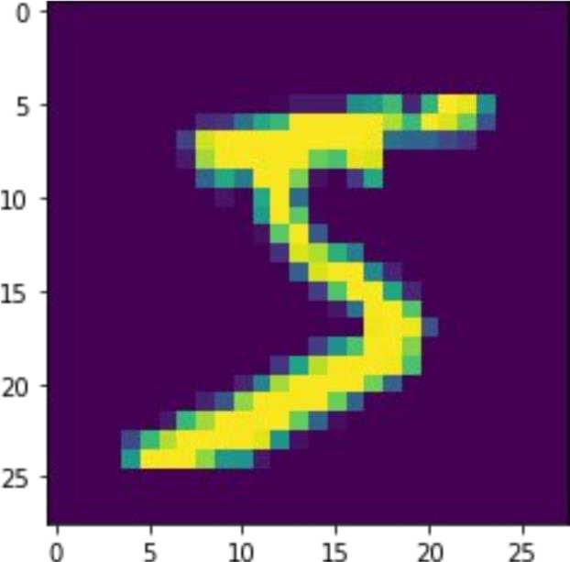

## Input:

plt**.**imshow(X_train[12])

Output:

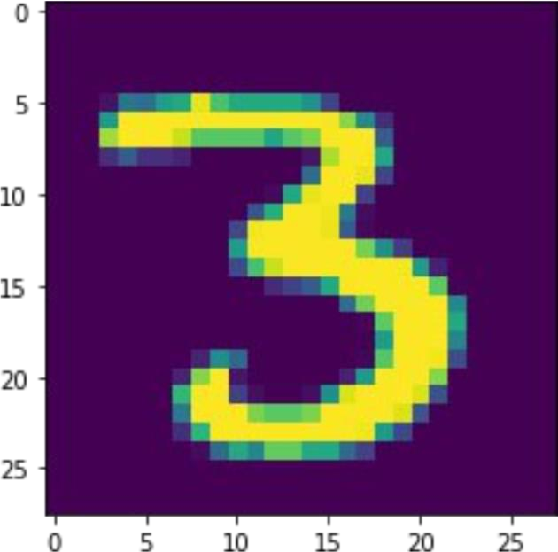

# Reshaping the data

X_train**=**X_train**.**reshape(60000, 28, 28, 1)**.**astype('float32')

X_test**=**X_test**.**reshape(10000, 28, 28, 1)**.**astype('float32')

# Apply one-Hot Encoding

number_of_classes**=** 10

y_train**=**np_utils**.**to_categorical(y_train, number_of_classes) y_test**=**np_utils**.**to_categorical(y_test, number_of_classes) Input:

y_train[0]

## Output:

array([0., 0., 0., 0., 0., 1., 0., 0., 0., 0.], dtype=float32)